

CST3133 Advanced Topics in Data Science and Artificial Intelligence Final Report

Part One: Machine Learning Workflow Model Development and Ethical Considerations
Part Two: Natural Language Processing and Deep Learning for Text Analysis
Created By Students: | Student ID:
Arbaaz Ali Hussain | M00872279
Nathan Amani Kagoro | M00910099
Cristian Tcaci | M00674787
ChingHsuan Tsai | M01001570

Module Leader: Dr Halil Yetgin
Submission date: 16/04/25, 23:00 pm
Faculty of Science and Technology
Department of Computer Science
Middlesex University London
Word Count: 2135
Table of Contents
1. Machine Learning Workflow and Ethics 3
1.2 Dataset Selection and Problem Definition 3
1.3 Data Preprocessing 4
1.3.1Observations 4
1.3.2 Removing Duplicates 4
1.3.3 Converting Written-Out Numbers to Digits 4
1.3.4 Forcing Numeric Columns 5
1.3.5 Handling Missing Values 5
1.3.6 Normalizing Inconsistent Strings 5
1.3.7 Mapping Ordinal/Yes-No Columns to Numeric 6
1.3.8 Outlier Clipping & Scaling 6
1.3.9 Final Check 6
1.4 Exploratory Data Analysis 7
1.4.1 Univariate Analysis 7
1.4.2 Bivariate Analysis 7
1.4.3 Multivariate: Correlation Heatmap 7
1.4.4 Preliminary Findings & Insights 8
1.4.5 Model Development and Evaluation 8
1.5 Ethical Considerations 11
2.Natural Language Processing and Deep Learning 12
2.1 Text Dataset Selection and Preprocessing 12
2.2 Dataset Selection 12
2.3 Data Cleaning 12
2.4 Preprocessing 12
2.5 Deep Learning Model Implementation 13
2.6 Evaluation and Insights 13
3. References 13
4. Appendices 13

1. Machine Learning Workflow and Ethics

1.2 Dataset Selection and Problem Definition
This section will use a dataset to expand our knowledge of machine learning algorithms. We chose to explore a “student performance dataset” by author, sourced from Kaggle. It contains various factors that may influence exam scores. This dataset was chosen for its variety of data types and large set of unique instances. It comes in at over 11100 unique instances.

The dataset includes both numeric and categorical variables, as well as missing values and inconsistent placeholders (e.g., "Not Available", "N/A", "NULL"). Our primary goal is to:
- Clean and standardize the data (fix missing values, unify categories, handle outliers, etc.).
- Perform a comprehensive EDA (univariate, bivariate, and correlation analysis).
- Generate preliminary insights about relationships in the data.

The dataset contains the following columns:

Numeric Categories
Hours_Studied
Attendance
Previous_Scores
Exam_Score

Ordinal Categories (Low, Medium, High)
Parental_Involvement
Access_to_Resources
Teacher_Quality Extracurricular_Activities
Motivation_Level

Other:
Internet_Access
Gender
School_Type
Learning_Disabilities
Peer_Influence
Distance_from_Home
Parental_Education_Level

1.3 Data Preprocessing
We loaded the dataset from a CSV file using Pandas. We specified a list of placeholders (["--", "N/A", "NULL", "Not Available", "Unknown", ...]) so that they would be read as NaN. Then we printed:

- Head of the dataset (df.head()) to see the first rows.
- Info (df.info()) to observe data types and non-null counts.
- Describe (df.describe(include='all')) for an overview of numeric stats (mean, std) and categorical stats (top, freq).

1.3.1Observations

- The dataset had missing values in many columns (both numeric and categorical).
- Some numeric columns (e.g., Hours_Studied, Previous_Scores) contained textual values (like "sixty-five").
- Ordinal categories ("Low", "Medium", and "High") appeared in inconsistent forms (like "low" and "high").
- Specific columns (like Attendance) had partial data.

1.3.2 Removing Duplicates
We removed duplicate rows (df.drop_duplicates()) to ensure each row was unique and then reset the index.

1.3.3 Converting Written-Out Numbers to Digits
We noticed entries like "sixty-five". We wrote a helper function (words_to_numbers) that:

- Splits words like "twenty-three" into numeric form.
- Returns NaN if unrecognised.
- We applied this to columns we expected to be numeric (like Hours_Studied, Sleep_Hours, Previous_Scores, etc.). This ensures we have actual numeric data rather than textual strings.

1.3.4 Forcing Numeric Columns
After dealing with textual numbers, we used pd.to_numeric(errors='coerce') to turn any leftover strings into NaN. We identified columns such as:

- Numeric: Hours_Studied, Attendance, Sleep_Hours, Previous_Scores, Exam_Score, Tutoring_Sessions, Physical_Activity, Family_Income.
- Any unconvertible entries became NaN.

1.3.5 Handling Missing Values
Numeric Columns: We imputed missing values with the median of each column.
Categorical Columns: We imputed missing values with the mode (most frequent category), ensuring that no columns remain with NaN.

1.3.6 Normalizing Inconsistent Strings
Some columns had variations like "Male"/"male"/"MALE". We standardized them by converting everything to lowercase, trimming spaces, and mapping them to consistent forms:

"low" → "Low", "medium" → "Medium", "high" → "High".
"male" → "Male", "female" → "Female".
"yes" → "Yes", "no" → "No".

This step ensures uniform category names.

1.3.7 Mapping Ordinal/Yes-No Columns to Numeric
Depending on the modeling plan, we either:

- One-hot encoded specific categorical columns (like School_Type, Extracurricular_Activities).
- Mapped ordinal categories ("Low", "Medium", "High") to numeric codes (e.g., 0.33, 0.66, 0.99).
- Mapped yes/no columns to 1.0/0.0.
- This step is crucial if we intend to feed the data into specific machine-learning algorithms that require numeric input.

1.3.8 Outlier Clipping & Scaling
For columns like Hours_Studied (which might have extreme values):

We clipped outliers at the 1st and 99th percentiles.
We optionally applied MinMaxScaler or standard scaling to keep them in a normalized range.
Motivation: Models can be sensitive to outliers; scaling can help specific algorithms converge faster.

1.3.9 Final Check
We ran:

- df.info() to ensure that no columns had missing data.
- df.describe() to see new summary stats after cleaning.

1.4 Exploratory Data Analysis

1.4.1 Univariate Analysis
Histograms / KDE for numeric columns: We plotted the distribution of columns like Hours_Studied, Attendance, Sleep_Hours, etc. We found that some columns were slightly skewed (e.g., Hours_Studied might have a tail above 30). Others were reasonably normal.
Boxplots for numeric columns: This helped us spot outliers. For example, Exam_Score might range from 50 to 100, with few outliers beyond typical bounds.
Countplots for categorical columns: We checked the frequency distribution of categories like Teacher_Quality (Low, Medium, High). We observed that “Medium” was often the most common category in columns like Parental_Involvement.

1.4.2 Bivariate Analysis
Pairplot among numeric columns: We used sns.pairplot to see pairwise scatterplots. This can highlight linear relationships. We observed that Hours_Studied might show a moderate positive correlation with Exam_Score.
Scatterplots vs. Exam_Score
We individually plotted each numeric column (like Attendance) vs. Exam_Score.
Insight: A mild correlation might appear for Previous_Scores vs. Exam_Score.
Boxplots / Violin Plots for categorical columns vs. Exam_Score
For example, we examined Teacher_Quality (Low/Medium/High) vs. Exam_Score.
Finding: Students in “High” teacher-quality classes had a higher median exam score than those in “Low” or “Medium.”

1.4.3 Multivariate: Correlation Heatmap
We created a correlation heatmap for numeric features using sns.heatmap(df.corr(), annot=True). Some highlights:
- Exam_Score might show a positive correlation with Previous_Scores and Hours_Studied.
- Attendance could be modestly correlated with Exam_Score.
- Some features might be nearly uncorrelated (e.g., Distance_from_Home or Peer_Influence if numeric-coded) with Exam_Score.

1.4.4 Preliminary Findings & Insights
Strongest Predictors: Previous_Scores have the highest correlation with Exam_Score. Hours_Studied also shows a moderate correlation.
Categorical Influences: Students with High teacher quality or High parental involvement often exhibit slightly higher exam scores.
Data Quality: The dataset had a significant portion of missing values in specific columns, but the median/mode filling approach helps preserve the row count.
Some columns, like Extracurricular_Activities or Internet_Access, might be heavily skewed (most entries are “Yes”), which can lead to less variance.
Potential Next Steps: Feature Engineering: Possibly combine Parental_Involvement and Teacher_Quality into a single “Support Score.”
Modeling: We can try regression (if Exam_Score is continuous) or classification (if we convert Exam_Score to pass/fail)

1.4.5 Model Development and Evaluation
Observing preliminary insights from the EDA, we explored machine learning (ML) algorithms to gain deeper insights into the dataset. We aimed to find the ML algorithm that best fit our dataset and see which features it deemed most important in predicting exam scores. This would tell us which features most affect the students' scores.
We began by splitting the data into features and targets. We then split the dataset into training and testing data, with 80% being for training and 20% being for testing. This data was inputted into several ML algorithms, each tested for the optimal hyper-parameters. In the end, a random forest algorithm.
The random forest model had an R2 score of 0.615 and a retained RMSE of 2.40. It confirmed our initial suspicions, citing attendance, hours studied and previous scores as the three most essential factors in predicting final exam scores. Below is an image ranking all variables by importance.
Figure 1. Feature importances in Random Forest ML 9
Figure 2. Evaluation metrics and confusion matrix for groups of 5 10
Figure 3. Evaluation metrics and confusion matrix for groups of 5 10
Figure 4. Evaluation metrics and confusion matrix for groups of 10 11
Figure 5. Evaluation metrics and confusion matrix for groups of 10 11
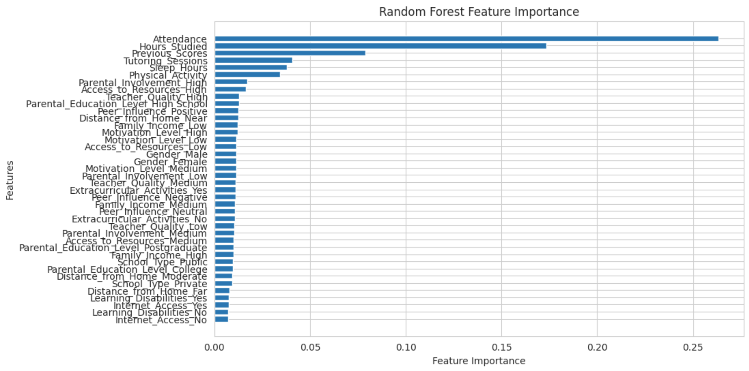
Figure 1. Feature importances in Random Forest ML

Although these proved our suspicions, we were not satisfied with the ML's accuracy. We attempted several methods of improving accuracy, such as using polynomial features and removing features with low importance, but none of these made a major difference.
We settled on having the ML try to place the score in a range rather than finding the specific score. This turned the problem from a regression task to a categorisation task. Other algorithms were tested again, but the random forest was still the most effective.
When predicting in ranges of 5, accuracy and precision were raised to around 78%. When predicting in ranges of 10, those numbers spiked to around 90%. All the while, the feature importance results maintained the same, further proving our hypothesis. Below are images displaying further metrics for the ML and confusion matrixes.

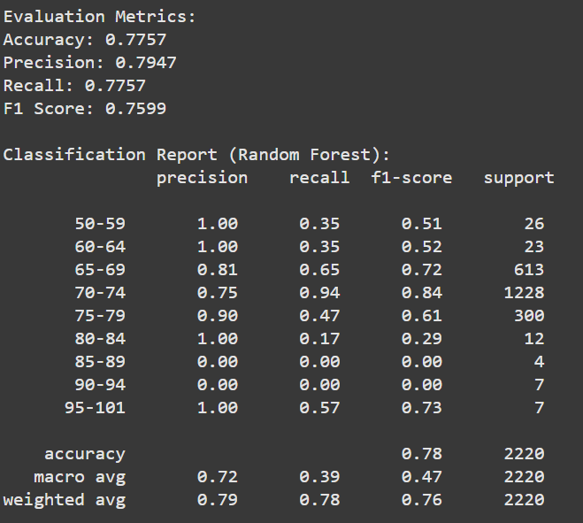
Figure 2. Evaluation metrics and confusion matrix for groups of 5
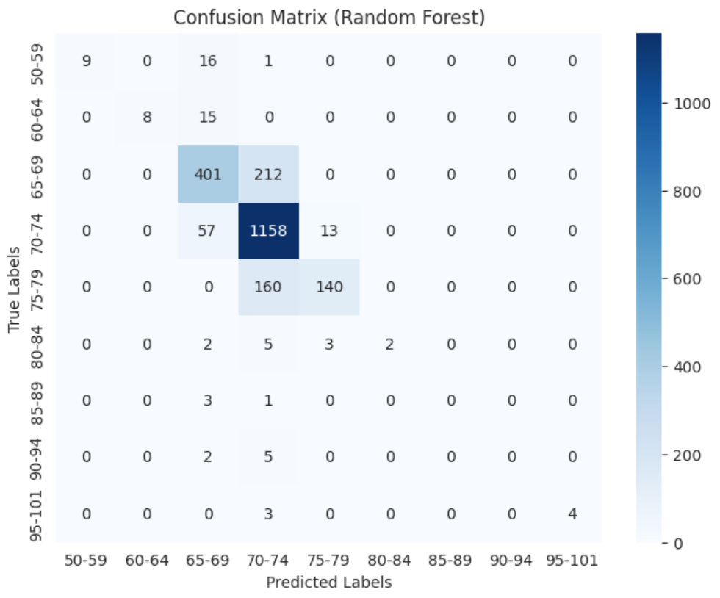
Figure 3. Evaluation metrics and confusion matrix for groups of 5

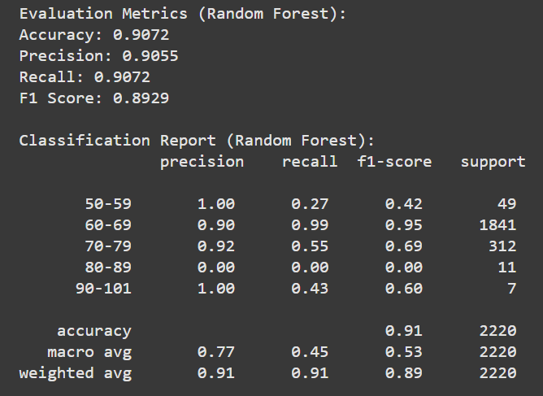
Figure 4. Evaluation metrics and confusion matrix for groups of 10
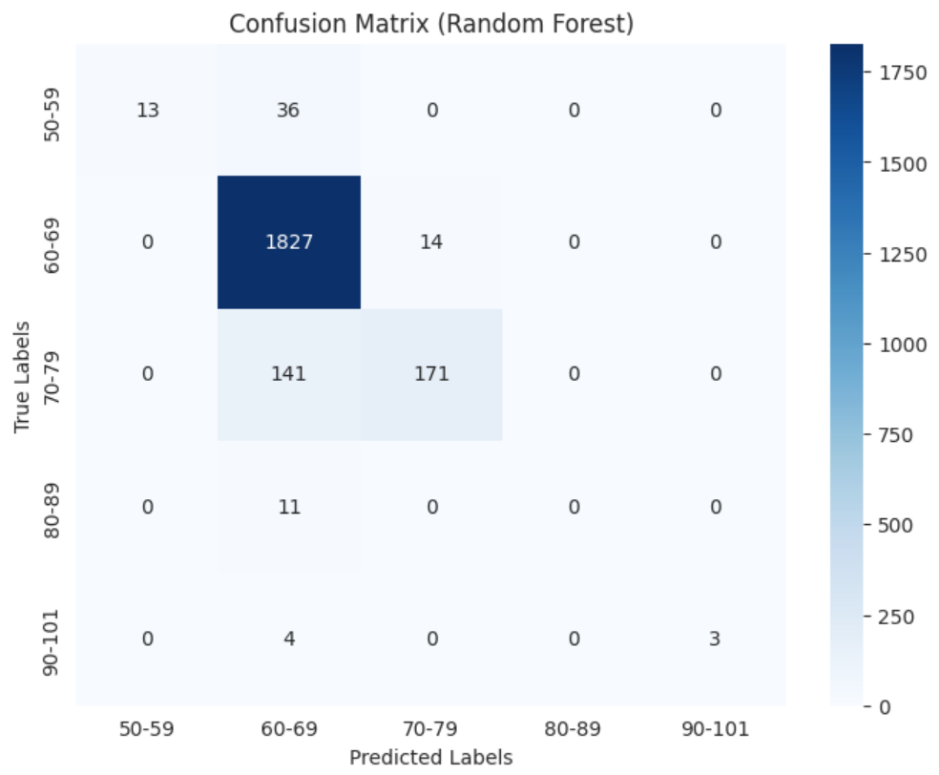
Figure 5. Evaluation metrics and confusion matrix for groups of 10

1.5 Ethical Considerations

2.Natural Language Processing and Deep Learning

2.1 Text Dataset Selection and Preprocessing
This section attempted to classify real vs. fake news data using deep learning models. Through study, data analysis and testing, we strived to find the optimal machine-learning algorithm to classify our data. This report shows our study's methodology, results, and insights we gained into natural language processing.

2.2 Dataset Selection
Firstly, we must describe the data set used in this experiment. The data set was “fake-and-real-news-dataset” by clmentbisaillon, sourced from Kaggle. This dataset was chosen for its perfect combination of simplicity in premise (binary categorisation) and its substantial amount of data. It sports just shy of 50,000 unique instances.

2.3 Data Cleaning
We began by loading the data, which came in two files, into separate variables. We then added a label column to each dataset. The fake news was labelled 0, and the real news was labelled 1. These two datasets were then merged into one variable, taking care to shuffle the data and adjust the indexes once merged.
We then checked the data for duplicates, of which there were none. This was followed by removing all stop words and contractions from the text. Stop words are commonly occurring words that typically do not carry much meaning. Contractions are shortened words. Both of these typically only serve to decrease the accuracy of machine learning models, as demonstrated later.

2.4 Preprocessing
We began preprocessing by tokenising the words. This turns all individual words left in the text into individual members of an array. A simple word split with spaces was used for this. We then built a vocabulary of the 20,000 most popular words in the text. Each of these tokens is then assigned an index, such that the words in the text sequences are replaced with these indexes.
If a word is not in the most common 20,000 words, it is assigned an unknown index. For uniformity, sequences are kept to 200 words. If a sentence exceeds 200 words, its sequence is truncated, whereas sentences short of the mark are assigned extra “padding” tokens. The data is finally divided into X values (The tokenised sequences) and the labels.
Lastly, we created a matrix of embeddings for the most common words. We used the glove.6B, 100d embeddings for this purpose. We first loaded the text file and then matched our most common words with the vector embeddings in the file. Words not present in the file were given default embeddings of 0. This left us with a 20,000 by 100 matrix of embeddings.

2.5 Deep Learning Model Implementation
The base of our deep learning model was a simple multi-layer neural network. We elected to use a Long-Short-Term Memory (LSTM) algorithm. An LSTM processes the text word by word, remembering past words as it reads new ones and uses that to predict or classify the whole sequence. It was chosen because it is particularly effective in sentiment analysis.

2.6 Evaluation and Insights

3. References

4. Appendices
Figure 1. Feature importances in Random Forest ML 9
Figure 2. Evaluation metrics and confusion matrix for groups of 5 10
Figure 3. Evaluation metrics and confusion matrix for groups of 5 10
Figure 4. Evaluation metrics and confusion matrix for groups of 10 11
Figure 5. Evaluation metrics and confusion matrix for groups of 10 11

